**University Model Assignment**

**Team:**

Nithin Dornipadu (002197358)

Dinesh Reddy Potlapati (002115486)

Sai Kiran Reddy Konda (002100788)

**Model Objective:**

The main objective is to develop a performance measurement solution for a university education and rank the universities accordingly. This will help students to get better understanding and make an informed decision while applying for universities.

**Proposed Solution:**

 The design will involve a set of parameters for evaluating the quality of education university such as graduation rate, student rating, alumni rating etc and an average will be considered to generate final ranking for the universities. The ranking will be visible to university admins for improving the education and students to decide if the university matches with their expectations. The dashboard will include admin, student, alumni, employer, and ranking system modules through which university administration can be done in addition to ranking.

*Considered factors*:

* Student vs faculty ratio(x1):
  + 100 - (total students/total faculty) is the formula used to calculate student vs faculty ratio.
* Intake vs graduate rate(x2):
  + (Total intake/total-graduate rate) is the formula used to calculate intake vs grad rate
* Graduate rate vs co-op ratio(x3):
  + (Total student secured co-op/total graduate rate) is the formula used to calculate graduate vs co-op ratio.
* Scholarships vs in-take(x4):
  + (Total students secured scholarship / total students in take) is the formula used to calculate ratio.
* Student rating(x5):
  + Average rating is calculated on total ratings from students.
* Alumni rating(x6):
  + Average rating is calculated on total ratings from alumni.

*Formula*:

UniversityRanking = ∑x(i) / 6

**The workflow of The University Model as follows:**

1. Admin will have the absolute authority to read, update and delete details of students, faculty, employee, and their directories. In addition, he can also add courses to the catalog and view the ranking of university.
2. Classes like Student, Faculty, Admin will have respective panels to access and modify the data. Alumni has a separate panel in which he can rate the courses which he pursued and view info like GPA and share if he is currently working in a company. For Example, the student panel will have access to modify the student directory of their own individual entity, whereas student cannot modify the professor directory.
3. In addition to showing info related to student in student panel, student can rate the course which will be used in university ranking.
4. Faculty can view their overall average rating which is calculated from student rating and can also add a request to director for starting a new course.
5. Based on the credentials used in the sign in page, the user will be logged into account with specific role like student, faculty and admin.
6. Admin can view the course rating, college ranking and University ranking from the respective panels.

**Business problems addressed:**

1. Quantified the performance of an academic unit using multiple factors like student rating, employer rating.
2. Based on the calculated performance, the academia is ranked, and this ranking can be viewed by admin as well as student.
3. All the respective roles will have access to their landing pages to modify the information.
4. Admin will have access to all information in a university.
5. Student will have access to below information:
   * Name
   * Contact Details
   * Address
   * Course List
   * Department
   * College name
   * Current GPA
6. University has access of college details where they can add or modify the data.
   * College class stores all the information mentioned below
   * College Name
   * College ID
   * Number of Departments
   * College Ranking
7. College class stores all the information mentioned below
   * Department Name
   * Department Courses
   * Department Ranking
8. Faculty class contains details of the faculty working in the college.
9. Employee class contains details of following information
   * Employee First Name
   * Employee Last Name
   * Employee Details
10. Alumni Class will maintain the records of students after their graduation.

**Business Rules:**

1. An admin can do multiple registrations of student, faculty, and employer
2. Admin, Student, Employer, and Faculty can login any number of times to view profile.
3. If Student, Faculty, and Admin forgets their password, using forgot password option, password can be reset.
4. Admin can also reset the password of all the actors like student, employee, and faculty.
5. University admin can access the data of all the colleges and has the access to view rankings when compared to another colleges.
6. Admins should have access to comparisons across colleges and universities to understand the college of ranking.
7. Private would be defined for all the class level member attributes.
8. The class level member methods may be defined as public/private/protected.
9. Alumni may or may not share the feedback of the courses pursued in the university

**Design Requirements:**

* Use UML class diagram.
  1. Each class represents a concept which encapsulates state (attributes) and behavior (methods).
  2. The name of the class appears in the first partition.
  3. Attributes, with their data types are shown in the second partition.
  4. Operations/Methods with the return data types are shown in the third partition. These are the functionalities provides by classes.
  5. “+” denotes public attributes or operations and “- “denotes private attributes or operations.
  6. Association, Inheritance, Composition and Aggregation were used accordingly to define the relation between classes.
* Use UML Sequence diagram
  1. Student, Faculty, Admin and Employer are referred as actors and classes like StudentDirectory, Feedback, RankingSystem etc are shown as classes
  2. The interaction between actors and classes are shown by using the defined methods in class diagram.
  3. Alternatives are used when needed to showcase if-else scenario.
  4. To show the time the class was active, activation was used on lifeline for representation.
  5. Response from class is represented by dotted line.

**CLASS DIAGRAM**

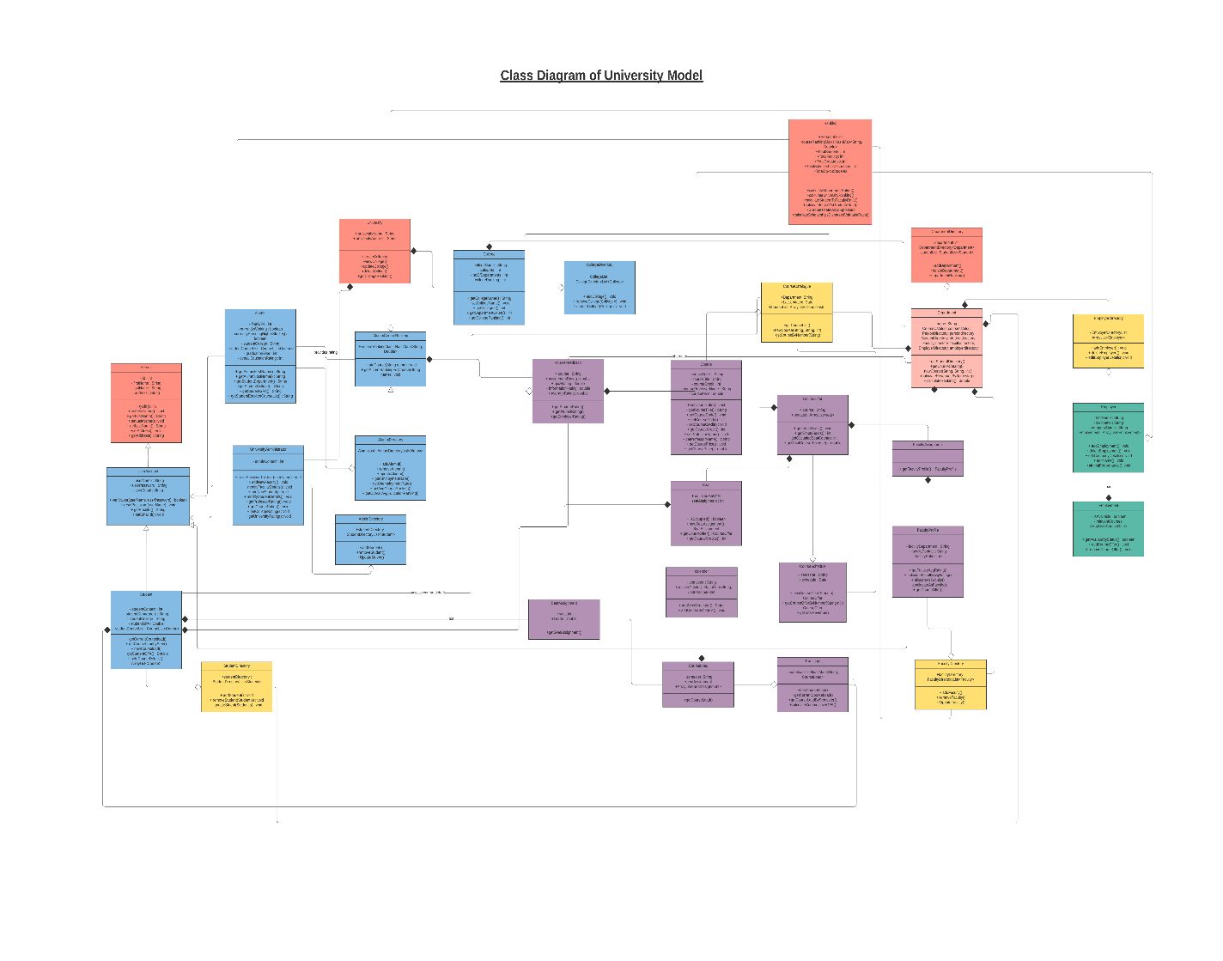

**SEQUENCE DIAGRAM**

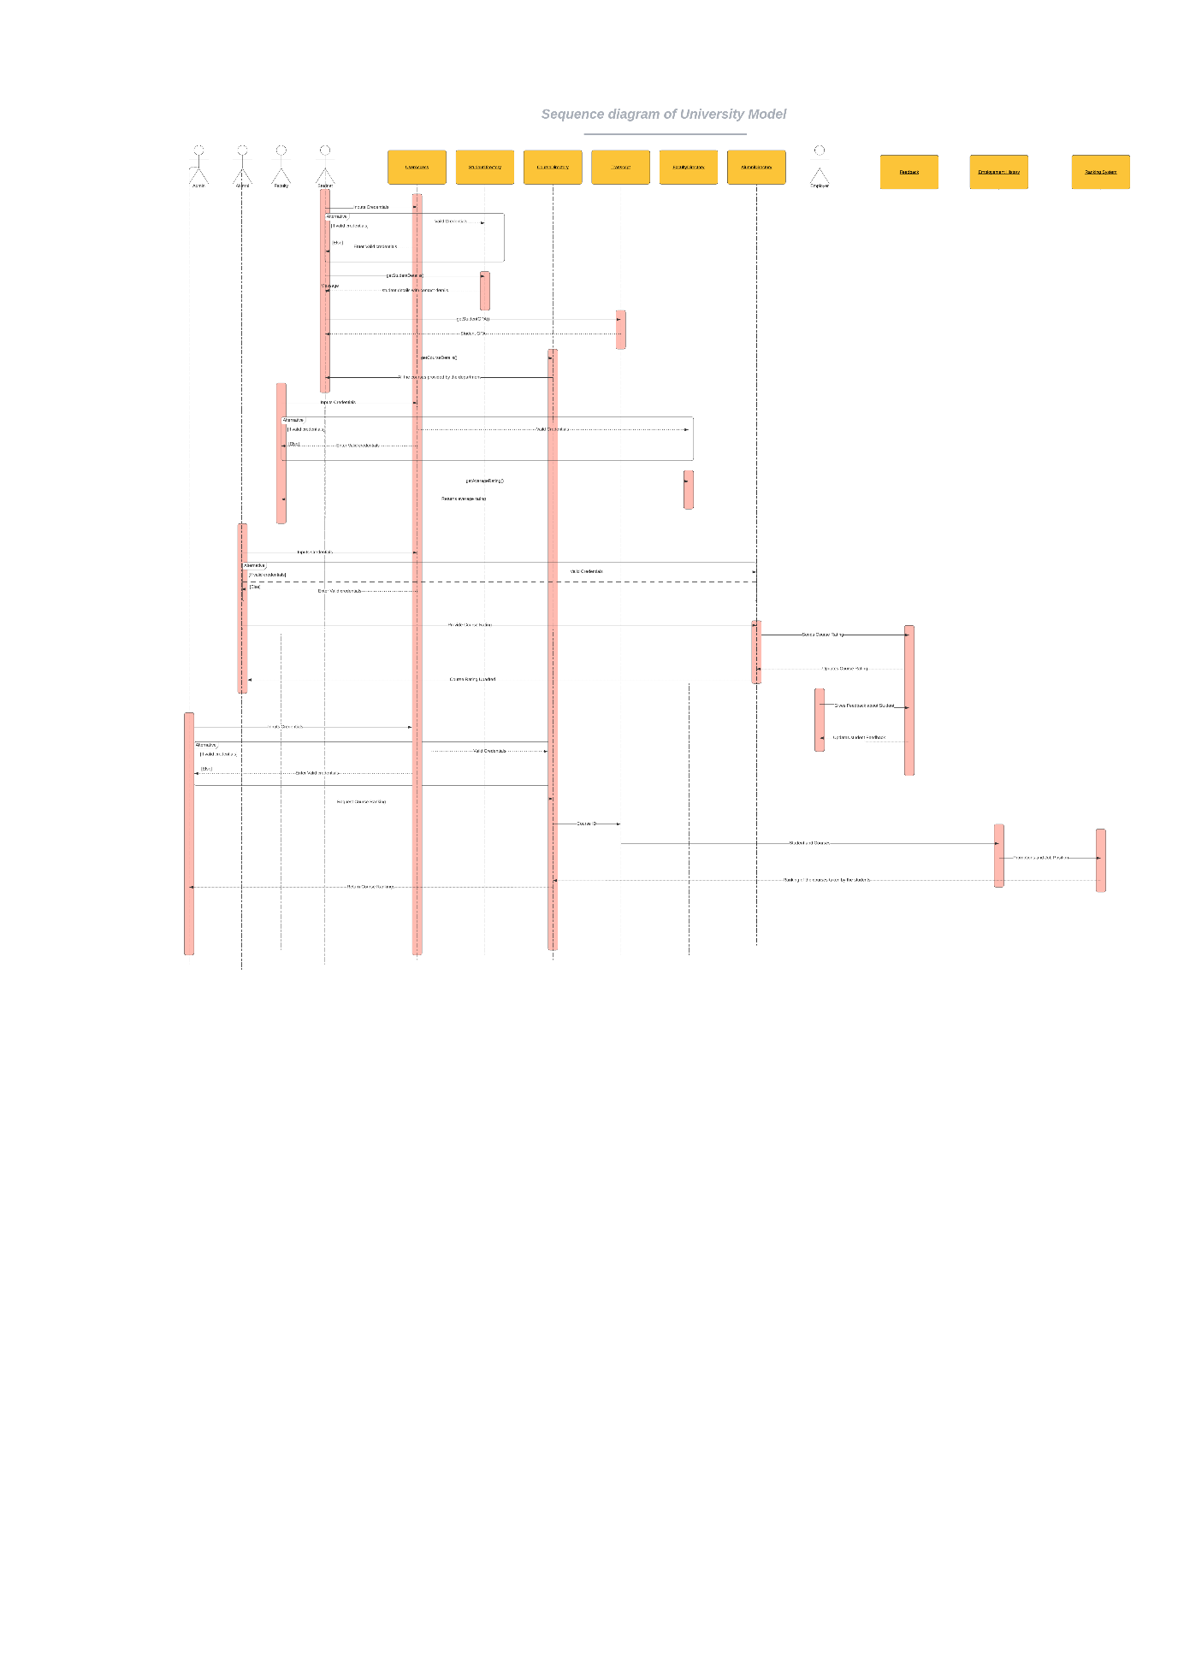

**USER INTERFACE**

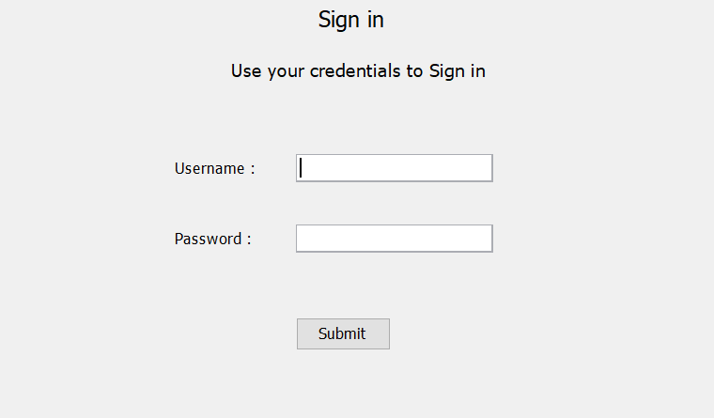

Sign in screen to validate the entered credentials and allow the user to access his account and other functionalities.

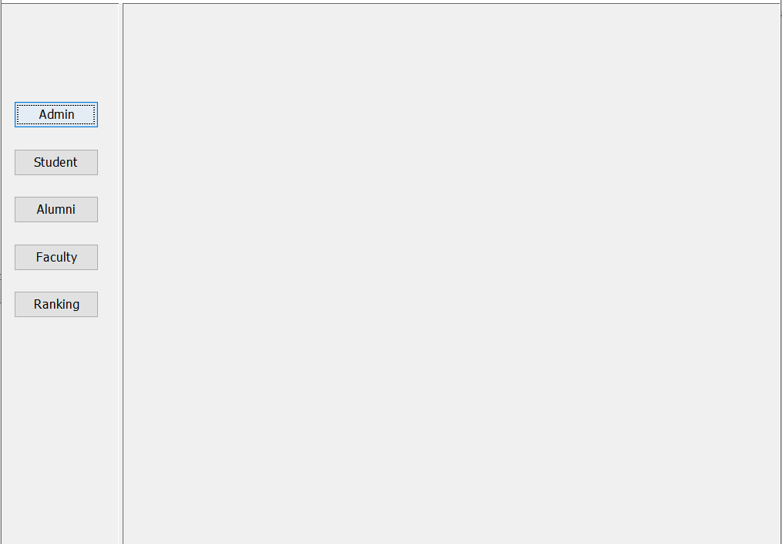

Landing page after logging into the system and this is the main menu of the application.

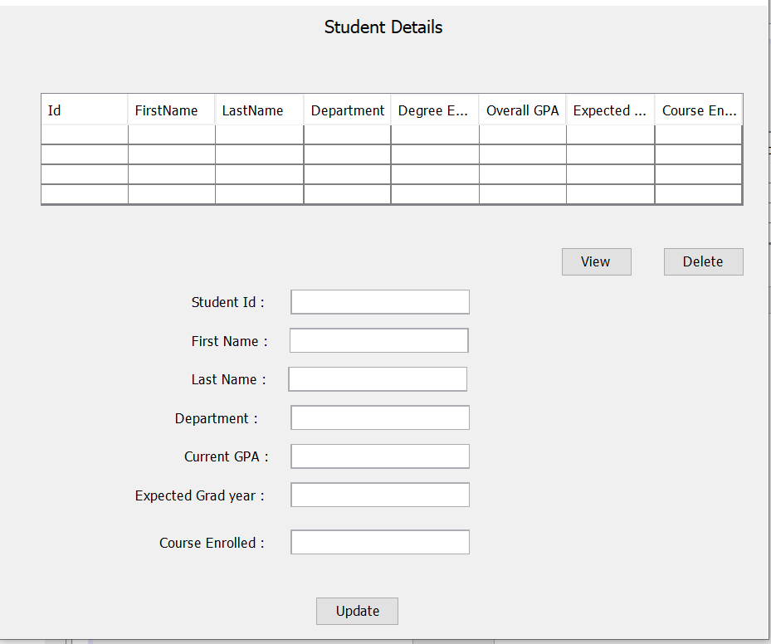

The above screen shot is a view of student info when logged in as admin.

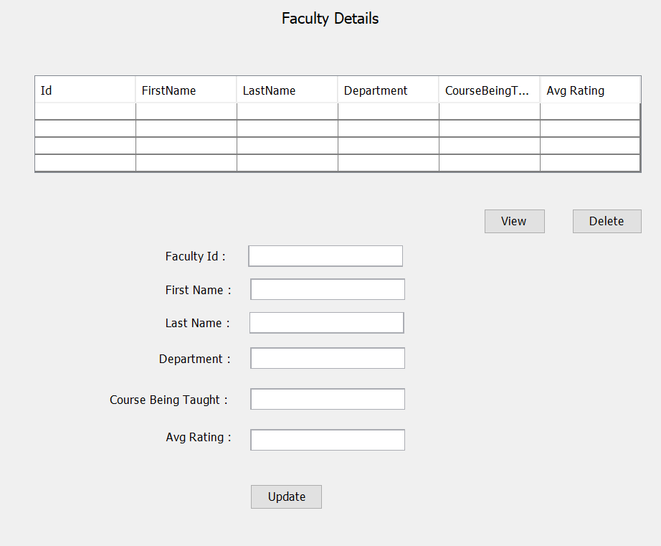

The faculty details panel is the view which is seen by user who is logged in as an admin.

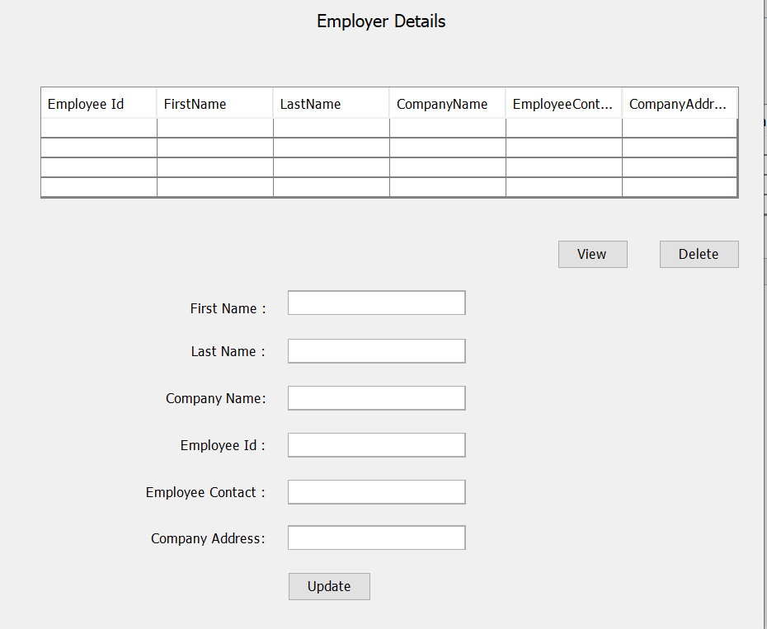

The view of the employer screen when logged in as an admin to view or edit the info of an employer.

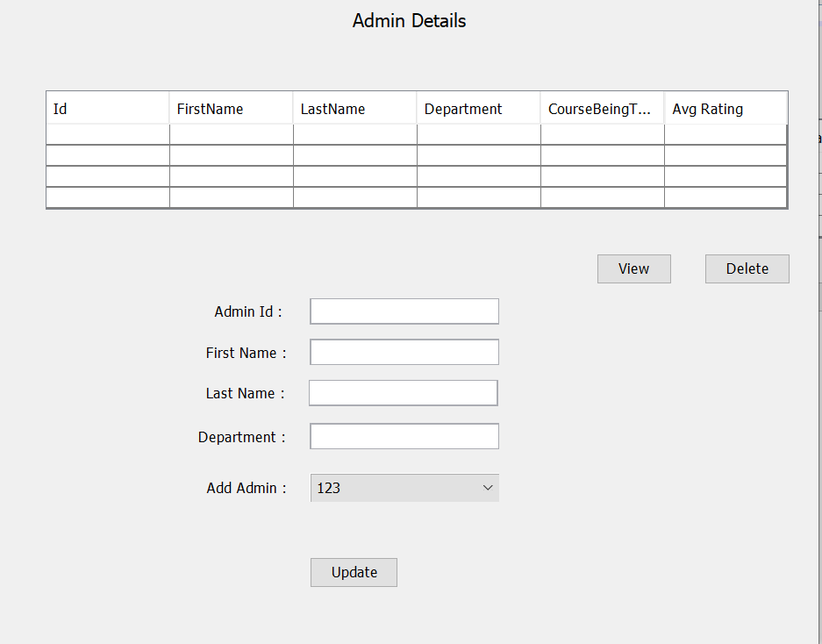

The above screen shows the multiple admin details. i.e, admin directory view when logged in as a admin.

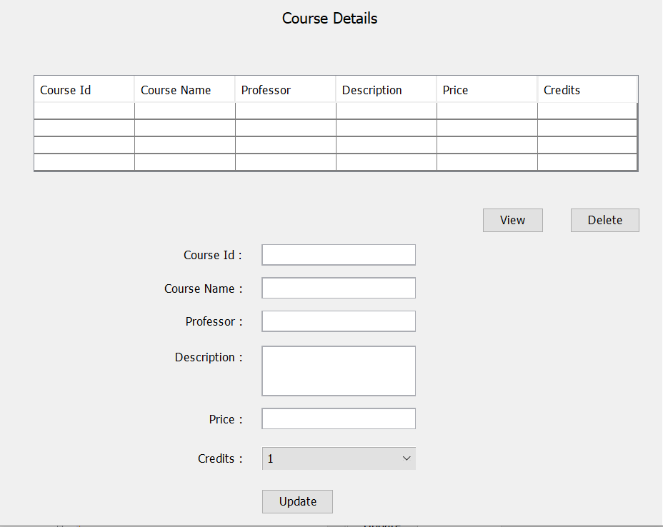

Course details screen viewed by used logged in as an admin.

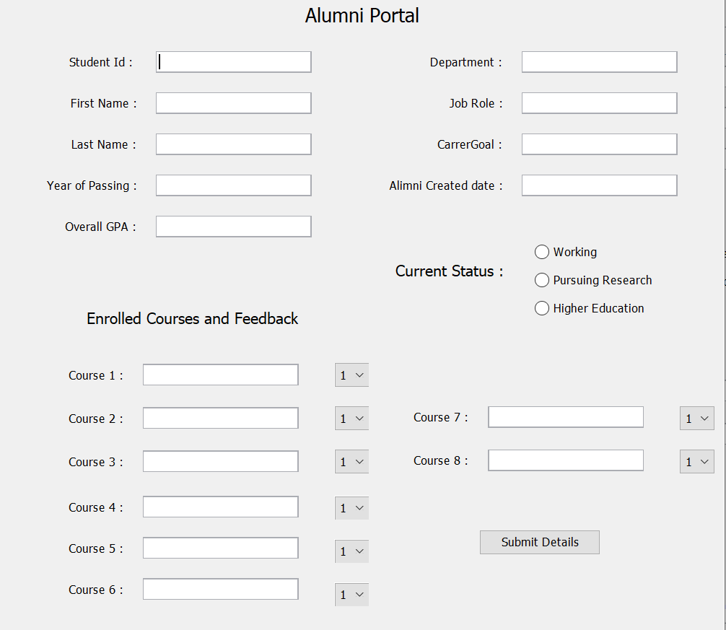

When logged in as an Alumni, the above screen is shown where feedback can be submitted to rate the university.

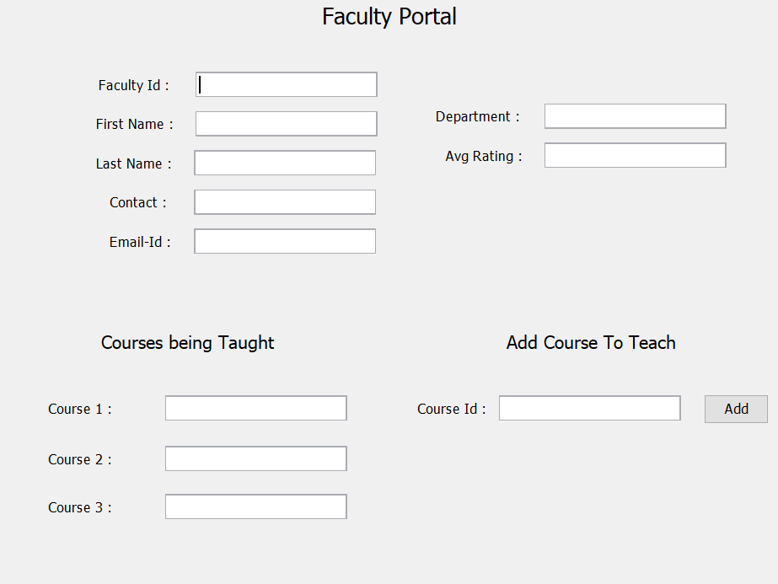

When logged in as a faculty, the above screen is shown with basic details like name, address and average rating. In addition, to teach a new course the professor can add the course-id to his list of courses that are being taught.

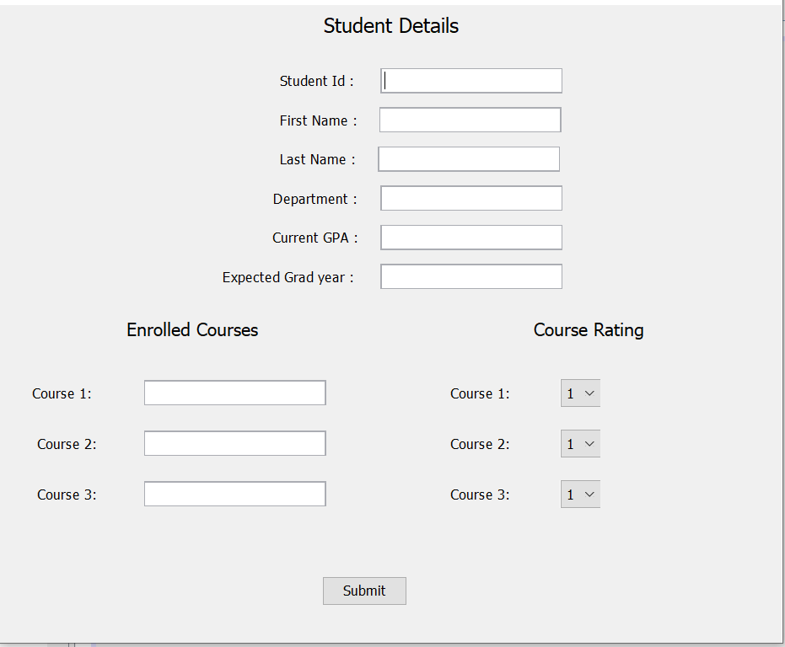

The above screen is displayed when logged in as a student and info like name, current GPA are shown. In addition to showing enrolled courses, rating can be provided in this screen which is considered in university ranking.

